Table of Contents
Introduction 2

Project Creation
- Mission 3
- Audience 4
- Goals and Objectives 5
- Concept Statement 6

Design
- Design Narrative 7
- Design Sketches 10
- Design Inspiration 12
- Potential Exhibition Theme 15
- Example Storylines 15
- Other Uses of the Proposed Exhibition Space 17

Production Logistics
- Potential Construction Phases 19
- Materials/Budget 20
- Development Plan for Walk of Fame 22
- Potential Funding Sources 24

Appendix A
- Sample Script for Minor League Baseball Panel
Appendix B
- Historical Summary
- Timeline of Damaschke Field
- Additional Research Resources
Appendix C
- Oneonta “Walk of Fame” Names
Appendix D
- Associated Photographs
Appendix E
- Price quotes and bids from fabrication firm

Introduction
In collaboration with members of the Oneonta community (Albert Colone, Principal, Colone Associates; Mark Simonson, Oneonta Historian; Sam Nader, former team owner; The Greater Oneonta Historical Society; and the City of Oneonta), graduate students from the Cooperstown Graduate Program in History Museum Studies formulated an exhibition concept plan for Damaschke Field. The proposed site, near the front entrance of the field, provides space for a community gathering area, as well as an opportunity to construct educational, interpretive panels for visitors to the stadium and Neahwa Park.
This plan provides an overview of design concepts and options, research about the history of Damaschke Field and the teams who have used the space, and options for financing the potential exhibition. This report will assist in the creation of an exhibition that benefits the community and shares the tradition of baseball in Oneonta.

Mission
Mission of the Greater Oneonta Sports’ Boosters:
The Greater Oneonta Sports’ Boosters is working in partnership with the Greater Oneonta Economic Development Council (GO-EDC) and the Otsego County Economic Council.
The Greater Oneonta Sports’ Boosters (GOSB) operates under the following mission statement:

The mission of the GOSB is to promote the Greater Oneonta area as a major year-round sports travel destination by growing, creating, and recruiting sports events; supporting those events and organizations; and encouraging community participation. These efforts are intended to result to in positive economic impact on the region and to improve the overall quality of life in the area.

Mission of the Damaschke Field Exhibition Space:
The proposed exhibition will provide a comfortable, educational, community space that is accessible to Central New York. A commemorative “Walk of Fame” and a series of outdoor panels will display the visual narrative of Damaschke Field.

Audience
During the 2012 Oneonta Outlaws season, approximately 1,550 individuals visited Damaschke Field per game, located in Neahwa Park in Oneonta, New York. Thousands more use the surrounding Neahwa Park for exercise, leisure, sports team and league competitions, and facility rentals throughout the year. Neahwa Park is open to the public and offers playgrounds, other baseball fields, a future water playplace, paved paths, a skate park, soccer fields, and community memorials. This proposed outdoor exhibition intends to attract a variety of people and groups, both local and visitors to the area.

Possible visitors include:
• Families
• Local Oneonta residents
• College students (SUCO and Hartwick)
• Baseball fans
• Walkers/runners/joggers
• People walking dogs
• Bicyclists
• Groups who use the field (baseball teams at a variety of levels, i.e. collegiate, recreational, Little League, etc.)
• Sports tourists and teams associated with events, tournaments, and attractions in the Greater Oneonta area including:
◦ Boxers
◦ Archers
◦ Roller derby participants and fans
◦ Amateur football
◦ Runners (5k and other races)
◦ Softball and baseball teams

Goals and Objectives
The outdoor exhibition will connect visitors to the historic landmark of Damaschke Field through these goals:

• More Than Baseball: Raise awareness of Damaschke Field as a community center of interaction and connection.

• Explore: Encourage visitors to experience surrounding Neahwa Park, downtown Oneonta, and the cultural offerings of the community.

• Educate: Allow visitors to learn the rich history of baseball and Damaschke Field by highlighting its storied past and encouraging preservation of the facility for future generations.

• Commemorate: Celebrate the men and women who contributed to the success of Damaschke Field through the Oneonta Baseball Walk of Fame (a brick path through the proposed exhibition site featuring names of key individuals, their team affiliation, and association with the field).

Concept Statement
Damaschke Field, located in Oneonta, New York, has served as an important community gathering space from 1905 to the present. The field reflects the changing dynamics of the city and has provided a space for citizens to gather and interact through the sport of baseball. A future exhibition, located in the green space near the field’s structure, will focus on the field and the community’s history from the early twentieth century to the present day. Rather than concentrating on the story from the narrative of the history of baseball, the core of the exhibition will come from personal narratives of community members and those people affiliated with the variety of baseball teams that have used the space. The continuing use of Damaschke Field for sporting and community events allows this exhibition to tell an important, personal story for visitors to explore today.
The field, located in Neahwa Park, primarily serves visitors to Damaschke Field and the surrounding Neahwa Park grounds. Marketing materials will focus on local residents, college students, and families; audiences to whom the exhibition will attract. A rectangular patch of grass approximately 3,900 square feet in area is available for a permanent, outdoor exhibition, which will include panels and a seating area of benches. Due to concerns about safety and weather conditions, no objects will be included. However, digitized photographs and a list of players who started their careers in Damaschke Field will be integrated into the outdoor panels and walk of fame.
A group of active community leaders has been assembled to consult on the project and assist in the direction of the exhibit’s story. The proposed exhibition will drive visitation to the site and associated marketing materials will align with the city of Oneonta’s overall plan to boost sports tourism to the region. This exhibition is currently not funded, but potential donors include community members, local organizations, and the city of Oneonta. Additional funding could be provided through grants and the Walk of Fame development opportunity.

Design Narrative
To explain the history of Damaschke Field, the design concept includes a central path with engraved bricks to honor important figures in Oneonta baseball history, as well as interpretive panels with integrated seating. Details about these conceptual features are explained below.
A central brick path through the exhibition site will direct visitors from the parking areas to the main entrance of Damaschke Field. The suggested focal point of this path is a baseball shape, in a contrasting color, with names of important figures engraved on the surface. These contrasting bricks can be arranged in a large, 30’ diameter circle, with additional bricks placed to replicate a baseball’s threads. Larger rectangular bricks placed in the main walkway can be engraved with a brief description, such as “Oneonta Walk of Fame.”
In addition to the commemorative and decorative brickwork, two half-circle shapes can provide space for the interpretive panels. These panels will educate visitors to Damaschke Field about the history of the stadium, as well as the history of baseball in Oneonta. These panels could have an integrated bench or seating option, which will allow for the outdoor exhibition space to be used as a comfortable gathering space.
These structures, which will be custom-built, should reflect the existing character of and materials within Damaschke Field. Inspiration for this shape stems from the existing low, long, arched sign that spans the main entrance gate. To make this sign a focal point, it is proposed to move this arched sign to the front of the green space, thus serving as an entry point to the “Walk of Fame.” It also allows the space to be used as a photo opportunity for visitors. This curved, arched, shape can be referenced in the general shape of the panel and seating along the concave portions of the proposed brickwork.
The upper portion of this custom steel structure will span approximately 18’4” and follow the curve created in the brickwork. The proposed frame has a mesh-like, diamond-shaped grid pattern that is approximately 4’ high. This concave, curved arch will provide a backdrop and support for four interpretive panels, while the open grid replicates fences often used behind home plate at baseball parks.
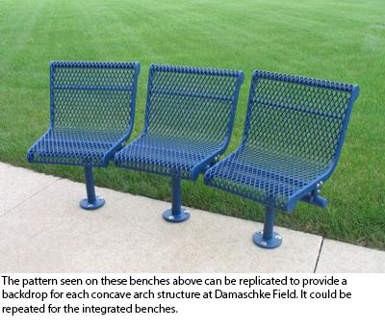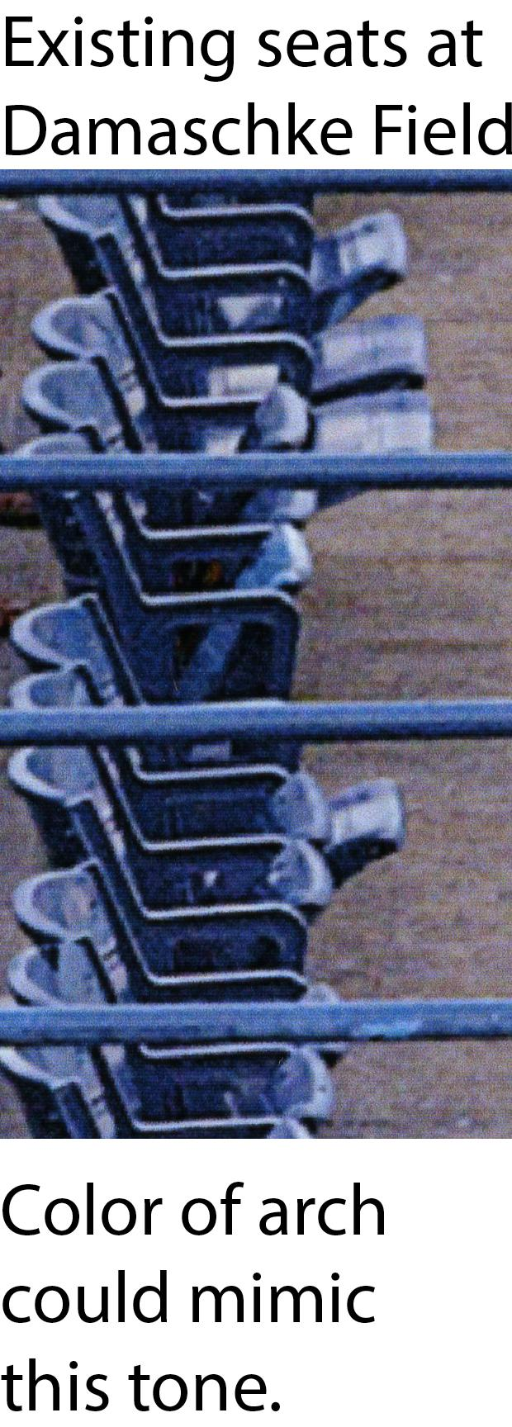
Four interpretive panels can be mounted onto each steel frame. These panels could be a straightforward rectangle or a more abstract form, based on the images used within the panel. In addition to the panels, shapes can be mounted on the upper portion - a headline could be printed on this shape, incorporating a baseball motif. Possible shapes for this headline could be a waving pennant or flag, a baseball bat, or even shapes that reference baseball concessions or snacks. Each headline shape provides opportunities to emphasize the emotions, fun, and sensory experiences when attending a baseball game. The curved shape suggested for the frame allows for a feeling of movement and playfulness - these motifs should be somewhat exaggerated to fill the monumental scale of each structure.
Each panel should have a consistent format and content should be based around photos from the time period being described. The use of bold colors will attract visitor attention and make for a dynamic viewing experience. Color choices could reference previous teams (for example, red for the Red Sox, blue for the Yankees, etc.) or the existing colors at the stadium. In addition to telling a visual story through photography with accompanying explanatory text, each panel could have a “featured figure”. This section could take the form of a sidebar to set it apart from the rest of the panel’s story. Information on this featured portion could include a headshot or action shot of the person being profiled with historical information and a description of their significance to Damaschke Field. These individuals could be players, managers, owners, staff members, or other people associated with Damaschke.
The arch could be mounted on a matching steel truss - these beams could be crossed in a similar diamond shape, echoing the grid, or straight into the ground. Whimsical beams could be formed to mimic crossed bats, adding visual interest on the reverse of the arch. A custom metal curved bench can be mounted into the lower section of the truss. As with the arch above, it should follow the curve of the concave circular section of the ground. A separation of approximately eight to ten inches could be between the bench seat and the lower border of the frame with interpretive panels.

Design Inspiration
In addition to existing materials at Damaschke Field, the surrounding landscape of Neahwa Park provided other examples of shape, form, and memorialization. Inspiration was drawn from circular patterns and metal material found throughout the park and the field.

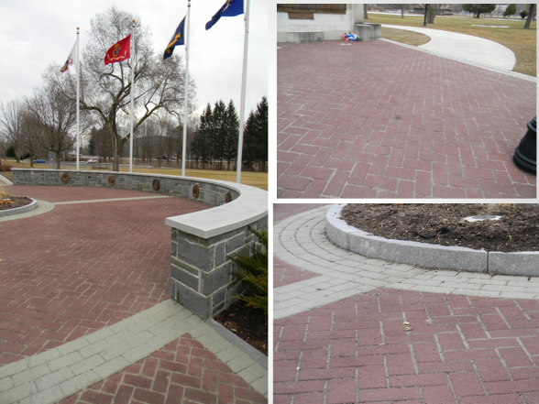
The Veterans’ Memorial in Neahwa Park employs patterned brickwork and a circular design to highlight the center of the site. 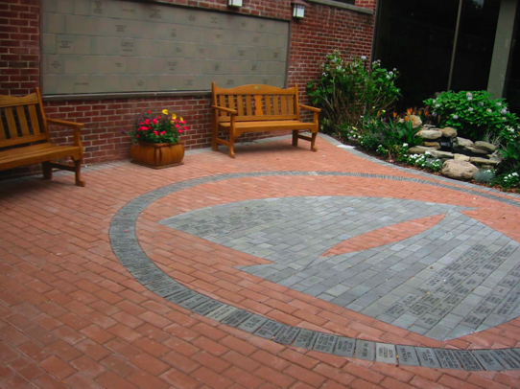

North Shore Monuments in Brookville, New York utilizes engraved bricks in patterned shapes to create innovative walkways, inspiring brickworks in the shape of a baseball for the Damaschke Field Walk of Fame. Found at: http://www.northshoremonuments.com/personalized-engraved-bricks.htm

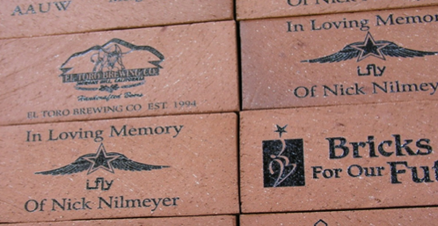
Laser engraved bricks, such as those found at www.engravedbricks.com, could serve as a fundraiser for the Walk of Fame. 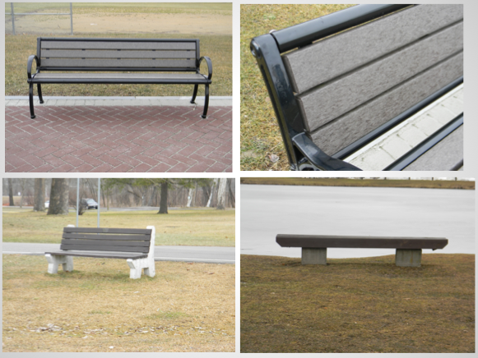
Neahwa Park currently features the above styles of benches.
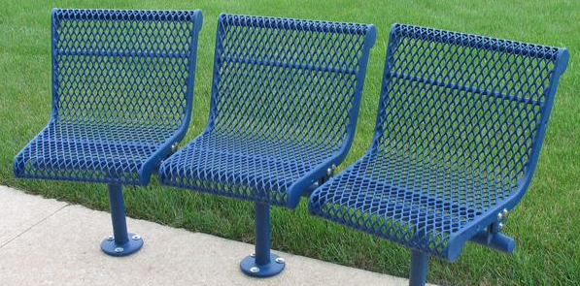
Metal, grated benches (such as those found at www.theparkcatalog.com) could be used as benches for the exhibition space. These benches, similar in design to those located in Damaschke Field, mimic the interior of the field.
Potential Exhibition Themes
Neahwa Park has served as an important community gathering space from 1905 to the present. The construction of Damaschke Field provided a new space within the park in the early twentieth century for Oneonta residents to participate in, and watch, recreational and professional sports events. The field reflects the changing dynamics of the city and allows interaction through the sport of baseball.

Example Storylines
Two large custom arched structures provides a backdrop and frame for interpretive panels. The images and text on these structures will contextualize the history of Damaschke Field and baseball in Oneonta. Suggested themes for these panels include: the history of baseball in Oneonta, minor league farm teams in Oneonta, and an overview of the history of the stadium. Damaschke Field has been the site of many non-baseball-related events over the course of its history; these community events could also be exhibited.

Minor League Professional Baseball in Oneonta
The story of minor league baseball in Oneonta could primarily focus on the 1940s through 2010, and feature information on the Oneonta Red Sox, Oneonta Yankees, and Oneonta Tigers. The involvement of community leaders such as Sam Nader and Sid Levine is a thread that connects each of these teams to the overarching historical narrative. The use of interviews, quotes, period images, and various newspaper articles provide contemporary contexts for the interaction of professional baseball players and Oneonta residents. See Appendix A for a sample script for a minor league baseball panel, with integrated historical photographs.

The History of Damaschke Field
Another suggested panel storyline is the history of the Damaschke Field facilities. As baseball became popular throughout the United States in the early twentieth century, demand for baseball venues also increased. Damaschke Field was constructed as a Works Progress Administration project in the mid-1930s before opening in 1939. A variety of community and sports events, in addition to baseball games, have taken place at the field, including: Fourth of July concerts, Mayor’s Cup soccer tournaments, high school football games, and concerts.
In order to encourage future preservation of the field and grounds, a portion of this panel could be devoted to the evolution of the field’s appearance from its opening to the present. Again, newspaper articles and images provide invaluable information about the various structural upgrades (such as the installation of lighting fixtures for night games) and other improvements.

Other Uses of the Proposed Exhibition Space
Programmatic Uses
The proposed exhibition space could be used for community social interaction in Oneonta. Programming and events such as autograph signings after baseball games, children’s books readings, special events with athletes, fitness classes, social meetups, and history lectures would appeal to both baseball fans and residents in the greater Oneonta area. The proposed structures, with integrated benches, provide sitting areas and a large open area for programs; additional seating could be brought out on the grass or on the brick path if needed.

Additional Exhibition Space
The harsh climate of upstate New York does not permit for the development of a museum outdoors without massive infrastructure creation. Facilities would require climate control throughout the year as well as constant surveillance and staff presence for security purposes. Additionally, object display cases, panels, and mounts would have to be purchased, installed, and maintained. Interpretive materials and rotating exhibits would need to be professionally developed, researched, and supervised. The long term collections care and management would likely be an expense that the city cannot afford; pest control would be a large undertaking that would have to be constantly surveyed.

One alternative to an on-site museum would be to pursue partnerships with organizations in the region in order to make objects accessible to the public. The Oneonta Historical Society, located in downtown Oneonta, could help explore the history of Damaschke Field in their existing space.

Partnerships with Other Organizations
Developing relationships with organizations in the Oneonta region and beyond can lead to a greater range of programs and exhibitions. By partnering with area institutions, the space can temporarily display objects related to the history of the field. Partnerships could also offset costs associated with programming and events. Some examples of potential partners are:
- Oneonta Historical Society
- Huntington Memorial Library
- Cooperstown Graduate Program
- SUNY Oneonta
- Hartwick College
- The Oneonta Parks and Recreation Department
- The New York State Parks and Recreation Department
- Cooperstown Dreams Park

Maintenance of the Current Space

Vandalism and general upkeep to the exhibition should be an ongoing process after the exhibition installation takes place. Responsible parties should have a clear idea of the role that they play within the clean up process if vandalism occurs defined by the Neahwa Park and Damaschke Field.

Potential Construction Phases
Phase 1 (2-4 years)
- Create budget
- City of Oneonta approval of material choices and plan
- Brick Paver Capital Campaign (see Development Plan)
- Contact inaugural donors (former baseball players, prominent community members, corporate sponsors) - raising at least $50,000 before construction begins
- Apply for grants (see Potential Funding Sources)

Phase 2 (6 months)
- Infrastructure and lighting
  - Removal of grass, laying sand for design footprint
  - Lighting installation and electrical preparation

Phase 3 (6 months)
- Lay brick path and create baseball shape (see Design)
- Contact panel and bench fabricators; confirm price quote and plan
- Continue Capital Campaign for site funding

Phase 4 (6 months)
- Installation of benches
- Installation of interpretive panels

Phase 5 (6 Months)
- Move Damaschke Field sign to front of exhibition space

Materials/Budget
Onontio Landscaping Inc.
Contact: Warren Osterhout
(607) 432-5098
www.osterhoutlandscaping.com
http://www.osterhoutlandscaping.com
Brickwork

Notes: Base would need to be prepared with 6 inch crusher-run. This would be compacted in layers; pavers would then be installed on a sand base. Poly-sand would be used to fill cracks between pavers and compacted in place. The range of cost takes into consideration both prevailing wage rates (because the land is city property) and types of pavers. No prevailing wage rates and economical concrete stonework or tiles would cost less than a prevailing wage rate and higher quality stonework. Additional details can be found in Appendix E.

Cost: $29,000 - $43,000 for the rectangular area, $1,700 - $2,600 for the balance
_______________________________

Artguild
Contact: David Egner
(856) 853-7500
www.artguildinc.com
http://www.artguildinc.com
Panel and Bench

Notes: The estimate for fabricating and installation of two (2) curved, metal mesh benches at Damaschke Field in Oneonta is attached in Appendix E. Artguild has made several assumptions in this pricing as noted. The city of Oneonta will need to provide engineered, level, concrete slab (or equiv.) onto which AGI would mount benches. No site conditions can require special equipment to offload and transport benches to install location, and pathway to install location is unobstructed. The metal mesh recommended in this pricing is a special flattened version that eliminates all ridges/distortions created by expansion (use of non-flattened version would reduce cost by $5,000) The version priced is one color, powder-coated steel. Additionally, if pennants are each colored independently, add $500 per color.

Cost: $37,000 if planned and made locally in Oneonta, $48,512 if planned and made off site

_________________________________

SeaReach
Contact: Ben Speidel
(503) 843-2005
www.seareach.com
http://www.seareach.com
Panel and Bench

Notes: The estimate for fabrication and installation of two (2) curved, metal mesh benches at Damaschke Field in Oneonta is attached in Appendix E. This is a rough estimate that could increase or decrease depending on construction methods (tbd), materials used, and additional design elements not yet specified. A price range to work with would be for the panels and structures without packaging and shipping.

Cost: $16,000 - $22,000

__________________________________

Lighting

Notes: The City of Oneonta has been replacing the existing High Pressure Sodium street light fixtures throughout the City with a mixture of LED and inductance fixtures. As part of the soon to be completed Parks Master Plan update, the city is planning on reconstructing the entrance to Neahwa Park from Market Street to allow for a pedestrian sidewalk over the Silver Creek alongside the James Georgeson Ave. As part of this plan, the City will replace the existing NYSEG owned cobra head street lights mounted on wood telephone poles with poles and LED fixtures in the same general design as the Memorial Walkway. More details concerning the fixtures can be found in Appendix E. These poles can be integrated into the exhibition space to ensure proper viewing and safety for visitors during night games at Damaschke FIeld.

Cost: TBD

Development Plan for Walk of Fame
Brick Paver Capital Campaign

The paved brick path at Damaschke Field provides an opportunity for outside funding sources to “sponsor” a name of a player or person associated with the teams that played at Damaschke Field. As oppose to other brick paver campaigns, the donor will be paying for a player name instead of their own message. Different monetary levels will give all community members the opportunity to contribute and create a deeper connection between community and the field.

Catcher’s Mitt Level- $60
- 4 X 8 brick with player name
- Two additional bricks on the path

Outfield Flyers Level- $125
- 4 X 8 brick with player name
- Coupon or two tickets to a summer game
- Five additional bricks on path

Home Plate Sliders Level- $250
- One brick with player name
- One brick with donor name or message
- Ten additional bricks on path

Owner’s Roster Level- $1,000 +
- One brick with player name
- One brick with donor name or message
- Recognition in the program
- Recognition in sign in Damaschke Field

Much like “sponsor an animal” campaigns at zoos, donors would receive a certificate of recognition with the name of the player sponsored in the brick paver in appreciation for their contribution. Donors would be recognized in the visitor program during the Outlaws season, in descending donation order.
Business level sponsorships will require additional recognition and benefits. Creating signage on the reverse side of the stadium for donations will encourage participation for the campaign. Announcements during games and invitations to the unveiling of the exhibition space upon completion will spur sponsorship at a higher level.

For more information, see:
http://www.thefundraisingauthority.com/fundraising-ideas/brick-fundraising/

Potential Funding Sources
New York State Office of Parks, Recreation, and Historic Preservation
Parks Program - Environmental Protection Fund
The Parks Program application is to be used for the acquisition, development and planning of parks and recreational facilities to preserve, rehabilitate or restore lands, waters or structures for park, recreation or conservation purposes and for structural assessments and/or planning for such projects. Examples of eligible projects include: playgrounds, courts, rinks, community gardens.
This program, administered at the state level, should be considered for partial funding of the outdoor exhibition space at Damaschke Field. The proposed exhibition project will increase community recreation space, assist with the ongoing efforts to revitalize Neahwa Park, and encourage preservation of the historic baseball stadium.
More information about the program, as well as a consolidated funding application, can be accessed by visiting http://nysparks.com/grants/grant-programs.aspx

New York State Department of Homes and Community Renewal
Office of Community Renewal - Rural Area Revitalization Projects
Applicants may request between $50,000 and $200,000 to perform community renewal activities in rural areas by creating innovative approaches to neighborhood and community revitalization which improve cultural and community facilities. While most of the grant funds have been previously used to improve housing and commercial spaces in distressed rural areas, the proposed exhibition space at Damaschke Field could appeal to the grant’s goal of increasing innovative cultural and community facilities.
In order to be eligible for the RARP grant, applicants to the program must have been engaged primarily in relevant community preservation activities for at least one year prior to application. The applicant’s officers, directors and members must be representative of the residents and other legitimate interests of the rural area.
Local support is needed at the city-level; the non-profits applying for the grant must obtain official approval from the City of Oneonta prior to applying. Other pre-application requirements and detailed information about the RARP program can be accessed by visiting the New York State Office of Community Renewal, at: http://www.nyshcr.org/Programs/RARP/
_________________________________

New York Council for the Humanities
Project Grant Programs
The NY Council for the Humanities provides small, matching, grants to non-profits who are undertaking projects to increase public programming and humanities awareness throughout the state. The NYCH’s “Planning Grant” provides up to $1,500 in matching funds to assist with the development of interpretive plans, while the “Project Grant” provides up to $3,000 for the actual implementation and execution of the exhibition concept plan. While this grant could not be used to fund materials and supplies for the proposed exhibition, funds could be used to further explore interpretation possibilities for the site at Damaschke Field. For additional information, deadlines, and sample applications for these grant programs, see: http://www.nyhumanities.org/grants/.
_________________________________

National Endowment for the Arts
“Our Town” Grant Program
The National Endowment for the Arts will provide a limited number of grants, ranging from $25,000 to $200,000, for creative placemaking projects that contribute toward the livability of communities and help transform them into lively, beautiful, and sustainable places with the arts at their core. Our Town will invest in creative and innovative projects in which communities, together with their arts and design organizations and artists, seek to:
• Improve their quality of life.
• Encourage greater creative activity.
• Foster stronger community identity and a sense of place.
• Revitalize economic development.
These goals, outlined by the NEA, are closely aligned with the goals of the proposed exhibition at Damaschke Field, as well as partners such as the Greater Oneonta Economic Development Council. This grant has incredible potential for the proposed exhibit if it is approached from the viewpoint of creating community space, highlighting the sense of place found in and around Damaschke Field, and tying it in with the downtown and Greater Oneonta economic efforts currently underway.
The proposed exhibition at Damaschke Field aligns with the Arts Engagement subsection of the “Our Town” grant, as outlined by the NEA (and underlined in this plan):
• Arts engagement projects support artistically excellent artistic production or practice as the focus of creative placemaking work.
• Innovative programming that fosters interaction among community members, arts organizations, and artists, or activates existing cultural and community assets.
• Festivals and performances in spaces not normally used for such purposes.
• Public art that improves public spaces and strategically reflects or shapes the physical and social character of a community.

The grant requires a multi-step process, the first of which is establishing partnerships. The NEA requires two primary partners: a non-profit entity and a local governmental presence. Suggested partners for the Damaschke Field exhibition installation could include the City of Oneonta, or even Otsego County.
For more information on “Our Town” through the National Endowment for the Arts, visit http://www.nea.gov/grants/apply/OurTown/Grant-program-description.html for a complete outline, list of requirements, and initial steps to take to begin applying for these funds.The NEA has also published a helpful guide that defines “creative placemaking,” which can be accessed at http://www.arts.gov/pub/CreativePlacemaking-Paper.pdf.
_________________________________

Appalachian Regional Commission
The Appalachian Regional Commission (ARC) is a regional economic development agency that represents a partnership of federal, state, and local government established by the Federal Appalachian Regional Development Act of 1965. Its goal is to improve the economy and quality of life in Appalachia by providing funding and technical assistance for projects in areas such as business development, education and job training, telecommunications, infrastructure, community development, housing, and transportation.
For more information, see: http://www.dos.ny.gov/lg/arc/
_________________________________

America’s Historical and Cultural Organizations: Implementation Grants
America’s Historical and Cultural Organizations grants provide support for museums, libraries, historic places, and other organizations that produce public programs in the humanities.
Grants support the following formats:
- exhibitions at museums, libraries, and other venues;
- interpretations of historic places, sites, or regions;
- book/film discussion programs; living history presentations; other face-to-face programs at libraries, community centers, and other public venues; and
- interpretive websites.

Implementation grants support final scholarly research and consultation, design development, production, and installation of a project for presentation to the public.
For more information, see: http://www.neh.gov/grants/public/americas-historical-and-cultural-organizations-implementation
_________________________________

United State Department of Agriculture: Rural Development Grant
The Community Facility Grant through the US DOA provides grants to assist essential community facilities in rural areas. Available to non-profit corporations, this money can assist in the development of community facilities. Grant funds can be utilized for the construction, enlargement and improvement community facilities for public services. Granting amount is based on average income of community members. This could provide funds for infrastructure changes ( like the sand before brick is laid) or the movement of the Damaschke Field sign to the front of the exhibition space.
For more information, see: http://www.rurdev.usda.gov/HAD-CF_Grants.html
_________________________________

New York Council on the Arts
The NY Council on the Arts accepts grant proposals each year from nonprofit organizations incorporated in New York State. If the Oneonta Historical Society would agree to partner on a grant, funds could be used to further explore the intersection of baseball and art at the Damaschke Field exhibition site. The Council’s overall funding is determined annually in the State’s budget, and no grants awarded are under the amount of $2500.00. Some grants are awarded on a single-year basis, and some grants are awarded on a multi-year basis. For additional information, deadlines, and sample applications, see: http://www.nysca.org/public/grants/index.htm
_________________________________

New York State Environmental Facilities Corporation
The NY State Environmental Facilities Corporation accepts Green Grant proposals each year from organizations that put forth projects related to various green initiatives. The Damaschke Field exhibition space would be eligible if construction incorporates at least one of the green infrastructure practices listed online, such as permeable pavements, downspout disconnection, or green roofs/walls. Grants awarded have totaled up to $250,000. For additional information, deadlines, and sample projects, see: http://www.nysefc.org/default.aspx?tabid=124.

Appendix A

Sample Script for Minor League Baseball Panel

HEADER: “I know of no better place for a young athlete to start his baseball career than Oneonta, New York." - George M. Steinbrenner III

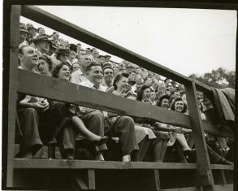
MASTER LABEL:

Since 1946, over 200 professional baseball players honed their skills in minor leagues at Damaschke Field. Oneonta, New York’s historic stadium hosted minor league farm teams from three Major League Baseball franchises – the Boston Red Sox, New York Yankees, and Detroit Tigers. Baseball’s legacy continues in Damaschke Field today, as collegiate and recreational teams use the field every summer.

SUBORDINATE LABEL #1 – ONEONTA RED SOX 1946-1951, 1966

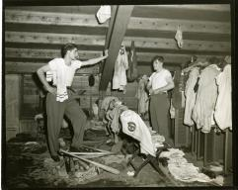
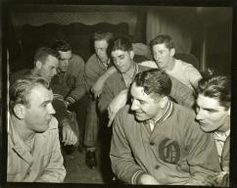
Spring in 1946 brought mild weather, sunny skies, and professional baseball to Oneonta. Local residents cheered when city officials secured the rights to the Canadian-American League affiliate of the Boston Red Sox. The Sox played at Damaschke Field until 1951.

The young men playing for the Oneonta Red Sox hoped to climb the ladder to the major leagues – and move from locker rooms beneath the Damaschke Field grandstand bleachers to the clubhouse at Fenway Park.

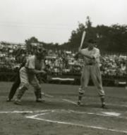
(Featured Player Section/Sidebar)
Oneonta was the starting ground to third baseman Frank Malzone’s major league career. Malzone was the first professional baseball player to reach the major leagues after playing for Oneonta-based farm team. After playing with the Oneonta Red Sox for the 1949 season, Malzone climbed the minor league ladder and had a successful, 11-season career with the Boston Red Sox from 1955 through 1966.

After 15 years without professional baseball, the Class A Red Sox returned to Oneonta in 1966 as part of the New York-Pennsylvania League (NYPL), where they would play for one season.

SUBORDINATE LABEL #2 – ONEONTA YANKEES 1967-1998

QUOTE: “It was the first time in my life that I ever gave my autograph to anybody.” – Lou Turco, Oneonta Yankees, 1974.
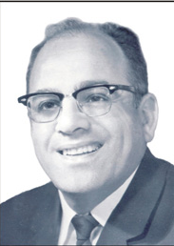
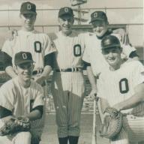
In 1967, The Oneonta Athletic Corporation, owned by Albert “Sam” Nader, purchased the team. Nader negotiated with the New York Yankees to place their Class A short season farm team in Oneonta. The affiliation, which lasted for 32 years until 1998, became the longest relationship between the New York Yankees and one of their farm teams.
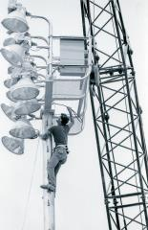

Record breaking crowds at Damaschke Field throughout the 1970s and 1980s hailed their home team. Improvements were made at the stadium, with the installation of lighting for night games and other structural upgrades.

Success on the field led to the popular “O-Yanks” winning eleven New York-Pennsylvania League championships between 1968 and 1998.

Several of the most popular New York Yankees played at Damaschke Field, including Don Mattingly, Bernie Williams, Andy Pettite, and Jorge Posada. Even legendary Denver Broncos quarterback John Elway played one year of professional baseball with the Oneonta Yankees over the 1982 season.

(Featured Player Sidebar/Section about Buck Showalter)

SUBORDINATE LABEL #3 – ONEONTA TIGERS 1999-2009

QUOTE: “Oneonta is our hometown and we want to keep baseball in Oneonta.” – Sam Nader

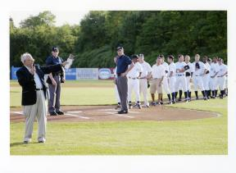

The efforts of Sam Nader and Sid Levine to maintain a baseball presence in Oneonta were praised by members of the community, who could often be seen posing for pictures during home games with their new mascot – Sam the Tiger. In October 1998, the Detroit Tigers Class A-Short Season farm team moved from Jamestown, New York to Oneonta. Initially a two-year contract, the Oneonta Tigers played at Damaschke Field from 1999 through the 2009 season. Tigers star center fielder Curtis Granderson began his professional baseball career with the Oneonta Tigers, batting .344 over the course of the 2002 season.
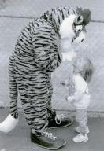

Appendix B
Historical Summary
Early History of Damaschke Field
The city of Oneonta, New York, has a long history with the game of baseball, with teams dating back to the 1860s. However, games were played at the former Central New York Fairgrounds, far away from the center of the town (where today’s Belmont Circle neighborhood is found) and difficult to get to. The first baseball field in Neahwa Park (at that time known as Morris Park) was built in 1905; the land was actually privately owned at the time by a Dr. Lewis R. Morris. With the intention of playing games for the public, a fence and small grandstand were built. The Oneonta Herald reported during this first game, “The grandstand was filled and along both the first and third base lines there were standing hundreds of men while there were not a few automobiles and carriages on the grounds.” The land was bequeathed to Oneonta in 1908 and a larger wooden grandstand was built on the property that same year. The name was officially changed in 1911 from Morris Park to Neahwa Park.
The history of summer collegiate baseball extends back to 1910 as “Collegiate players from Brown, Holy Cross, Syracuse, and Williams College played ball there in summers circa 1910-1912”; the grounds of the field continued to be improved as more teams started to use it. However, the field was primarily used for exhibition and recreational games throughout the 1910s and 1920s. Babe Ruth played an exhibition game at the field on Friday, October 15, 1920; the city even threw a parade in honor of his visit. Besides collegiate and exhibition games, the space was by the community for such events as the popular annual Police vs. Firefighters. In 1921, the first professional baseball team came to play at the field; known as the Oneonta Giants, they were part of the New York-Pennsylvania league and played at the field until 1924. Coached by “Big Ed” Walsh, the team struggled to attract major audiences like the exhibition games did. The Oneonta Indians (a B league team), another New York- Pennsylvania league team, played at the field for just one season in 1924.
As professional teams started to use the field, the park underwent major renovations. In 1923, running water was added along with a new fence, parking, sidewalks running from downtown to the field, and “overall beautification” to the park. The park was becoming a major draw in the central New York region. However, when the Oneonta Indians left in 1924, professional baseball would not return to Oneonta until 1940 with the Oneonta Indians, a Canadian-American League C-team. The team left as the had “difficulty in booking games and lukewarm support of the fans” and often games “were a financial loss.”
Just as the teams suffered financial losses, so did the field; without financial support, Neahwa Park was neglected. As the field did not undergo improvements for many years, it needed major renovations by the late 1930s;the wooden grandstand was recognized as major fire hazard by the city. Along with 2,500 other stadiums in the country, the field received funding from the WPA to build a steel grandstand in 1939. With this drastic improvement, the city funded lights to be installed in the stadium in 1940, allowing for more games to be played at night.
Organized baseball returned to Oneonta in 1940 with the arrival of the Class C Canadian-American League. The Oneonta Indians, managed by Lee Riley, played the 1940 season at Damaschke Field; the league continued to have a presence in Oneonta in 1941 and 1942 when the Oneonta Indians became affiliated with the Boston Red Sox, not the Cleveland Indians unlike popular belief. The Oneonta Indians were the 1941 league champions and brought crowds once more to the field. The Canadian-American League went on a three-year hiatus during World War II. When the league resumed, the Oneonta team name switched from the Indians to the Red Sox, and continued as such from 1946 until the disbandment of the Canadian-American League in 1951. From 1951-1966, no professional baseball teams played in Oneonta - use of the field and grounds was limited to recreational and municipal purposes.

Minor Leagues Play Once More
The New York-Pennsylvania League (NYPL) of minor league professional baseball returned to Oneonta’s Neahwa Park at the beginning of the 1966 season. The team played a shortened season, starting in mid- June and ending in early September, with only a few days off. The late start of the season was designed for college players to finish their spring seasons at college and enter directly into a competitive league. These players were placed in the homes of community members during their short stay in Oneonta, tightening the bond of professional baseball and the Oneonta community.The Oneonta Red Sox, Class A affiliate of the Boston Red Sox, opened the home season on Sunday, April 24, 1966, against the Binghamton Triplets. However, Oneonta’s association with the Boston Red Sox was short-lived.
In 1967, Oneonta Mayor Albert “Sam” Nader’s company, the Oneonta Athletic Corporation, purchased the team and negotiated a new affiliation with the New York Yankees; this relationship would remain in place until 1998. Nader issued an official proclamation on June 20, 1967, declaring Friday, June 23, 1967 as “Welcome To the Oneonta Yankees Day” in honor of the opening home game of the NYPL team.
The Oneonta Yankees (also affectionately termed the O-Yanks) had a strong start to the franchise, winning back-to-back NYPL championships in 1968 and 1969. The Oneonta Yankees repeated as NYPL champions in 1971, 1974, 1977, 1979, 1980, 1981, 1985, 1988, 1990, and 1998. A number of famous major league baseball figures spent time with the Oneonta Yankees, including Don Mattingly (1979), Bernie Williams (1987), John Elway (1982), Andy Pettite (1991), Jorge Posada (1991), and Buck Showalter (Manager, 1985-1987).
Prior to the opening of the 1992 season, the Oneonta Yankees organization was required to perform major renovations to Damaschke Field in order to maintain their association with Minor League Baseball, in compliance with the 1991 National Association of Professional Baseball League’s Professional Bargaining Agreement. Upgrades to the park as a result of the PBA included increased handicapped accessibility, updates to the plumbing fixtures, and increased concessions spaces. The scoreboard was renovated to include the player at-bat, and team facilities such as the clubhouses and training rooms were improved.
As of the end of the 1998 season, the Oneonta Yankees had been the oldest farm club within the New York Yankees organization. In September 1998, the New York Yankees ended their 32-year affiliation with Oneonta and moved their Class A-Short Season farm team to Staten Island, New York. While many Oneonta residents were saddened by the departure of the Oneonta Yankees, Sam Nader and Sid Levine worked to ensure that minor league baseball would continue to have a presence at Damaschke Field; an effort appreciated by the greater Oneonta community.
Just one month after the New York Yankees declined to renew their contract with Oneonta, the Detroit Tigers announced that their Class A-Short Season team would move to Oneonta from Jamestown, New York. Initially brokered as a two-year deal, the Oneonta Tigers played at Damaschke Field from 1999 through the 2009 season. The 100th anniversary of Damaschke Field was celebrated during Oneonta’s affiliation with the Tigers during the 2005 home opener, drawing 1,047 fans.
Additional renovations took place at Damaschke Field in 2006 during the town’s affiliation with the Detroit Tigers. The renovations, a $12 million project from NYSEG due to contaminated soil on the property, included the installation of a 4,600 square-foot clubhouse, a 450 square-foot concession stand, and new restrooms. The new renovations brought in more fans than ever before to Damaschke Field.
Citing economic difficulties and decreasing ticket sales, the Detroit Tigers moved their Class A-Short Season farm club from Oneonta to Norwich, Connecticut, after the 2009 baseball season. With the departure of the Tigers came the end of Oneonta’s 44-year association with the New York-Pennsylvania League. The Tigers’ exodus resulted in the organization paying a fee for breaking a “commitment to the community” clause in the contract. When former owners Sam Nader and Sid Levine sold the team in 2008, the resulting contract stated that the Tigers would have to remain in Oneonta through at least the 2010 season.
In March 2010, it was announced that Damaschke Field would continue to host organized baseball games over the summer, with the arrival of the Oneonta Outlaws. The Outlaws are one of 11 teams in the New York Collegiate Baseball League, a wooden bat developmental league for college students. Men who play in the NYCBL have not yet signed a professional agreement with a Major League Baseball team and the short 40-game season does not interfere with collegiate-level play or eligibility. The Oneonta Outlaws, NYCBL Champions of the 2011 season, continue to use Damaschke Field for all home games.

Damaschke Today
As the Outlaws have a short season, the field is continued to be used as community space for the greater Oneonta area. Thousands come every year to enjoy fireworks, concerts, and baseball games played by local schools and colleges. New bleachers have been added behind the original box seating area to encourage families to gather and eat together. The concession stands have recently seen a makeover, and improvements continue to made in the field every year, ensuring Damaschke will continue to be a clean, functional space.
The memory of the Oneonta Yankees and the Oneonta Tigers still runs strong today in the central New York area. The Oneonta Yankees have a very active facebook page; alumni and fans hold a reunion every few years in Oneonta. Community members continue to host Oneonta Outlaw players, just as they had with the Yankees and Tigers. Though Oneonta may have lost their minor league, Damaschke Field continues to be a community space for baseball and will be for years to come.

Timeline of Damaschke Field

1905 - Ballpark is built on Neahwa Park site.
1908 - The land the current field is on is bequeathed (known then as Morris Park)to the city and the wooden grandstand is built.
1910 - Collegiate players from Brown, Holy Cross, Syracuse and Williams College played baseball on the site.
1911 - The name is officially changed from Morris Park to Neahwa Park.
1920’s - Exhibition games are played by various teams and players, including Babe Ruth and Mickey Mantle.
1921 - The Oneonta Giants, in the New York- Pennsylvania League, start playing on the field.
1924 - The Oneonta Indians (class B team), in the New York- Pennsylvania League, start playing on the field.
Aug. 16, 1930 - The first night game is played on the field between Oneonta Red Sox and the California Owls.
1939 - The current steel grandstand is built for $5000 by WPA Funds.
1940 - Lights are installed in stadium
1940-1942 - The Oneonta Indians (class C team), in the Canadian-American League, play on the field.
1946-1951 - Oneonta Red Sox (class C team), in the Canadian-American League, play on the field.
1966 - The Oneonta Red Sox (class A team), in the New York- Pennsylvania League, play on the field under Sam Nader’s corporation, the Oneonta Athletic Corp.
1967-1998 - The Oneonta Yankees (short season A- team), in the New York- Pennsylvania League, play on the field.
1968 - The field is renamed “Damaschke Field” after “Dutch” Damaschke, the former vice president of the Oneonta Red Sox.
1968 - The Oneonta Yankees win their first New York- Pennsylvania League championship.
1969 - The Oneonta Yankees win the New York- Pennsylvania League championship.
1971 - The Oneonta Yankees win the New York- Pennsylvania League championship.
1972 - Terry Whitfield sets the club’s record for most runs in a season and ties the record for most triples in a season.
1973 - Neal Mersch sets team record with 11-0 record. Kerry Dineen sets team record for highest batting average in a season (.365).
1973 - Damaschke Field receives batting cage from the New York Yankees.
1974 - The Oneonta Yankees win the New York- Pennsylvania League championship; Greg Diehl pitches a perfect game.
1975 - The Oneonta Yankees lineup features nine future major leaguers.
1977 - The Oneonta Yankees win the New York- Pennsylvania League championship.
1978 - The Oneonta Yankees win their division title.
1979 - The Oneonta Yankees win the New York- Pennsylvania League championship.
1980 - The Oneonta Yankees win the New York- Pennsylvania League championship.
1981 - The Oneonta Yankees win the New York- Pennsylvania League championship.
1982 - Future Football Hall of Famer John Elway plays with the team.
1984 - Darren Mandel sets team record for most home runs in a season (13).
1985 - The Oneonta Yankees win the New York- Pennsylvania League championship.
1985 - Future Major League Manager Buck Showalter coaches the team.
1986 - The Oneonta Yankees win their division title.
1988 - The Oneonta Yankees win the New York- Pennsylvania League championship.
1989 - Sherman Obando ties the club record for most doubles in a season (23).
1990 - The Oneonta Yankees win the New York- Pennsylvania League championship.
1993 - Massive renovations take place on Damaschke Field in order to retain affiliation with minor league- including the installation of drinking fountains, new concession stands, handicap accessibility, clubhouse, training room, and the creation of umpire facilities.
1993 - Ruben Rivera ties the club record for most home runs in a season (13).
1995 - Jay Tessmer sets the club record with 20 saves in a season.
1996 - Luis DeLosSantos pitches a no-hitter.
1997 - The Oneonta Yankees finish with the New York- Pennsylvania League’s best record in the regular season.
1998 - The Oneonta Yankees win the New York- Pennsylvania League championship.
1999-2009 - The Oneonta Tigers (short season class A-), in the New York- Pennsylvania League, start to play on the field.
2006-2007 - Massive renovations take place on Damaschke Field, a $12 million project from NYSEG, because of contaminated soil; includes the installation of a 4,600 square-foot clubhouse, a 450 square-foot concession stand, and new restrooms.
2007 - Guillermo Moscoso pitches the second perfect game in the New York- Pennsylvania League’s history.
2010- Present - The Oneonta Outlaws (short season team), part of the Collegiate League, start to use the field.

Additional Research Resources

The National Baseball Hall of Fame Museum and Library
24 Main Street, Cooperstown, NY
1-888-HALL-OF-FAME
The Greater Oneonta Historical Society
183 Main Street, Oneonta, NY
607-432-0960
Julie Lewis, Chief Photographer, The Oneonta Daily Star
102 Chestnut Street, Oneonta, NY
Huntington Memorial Library
62 Chestnut St, Oneonta, NY
(607) 432-1980
Mark Simonson, Oneonta Town Historian
info@oneontahistorian.com
Brian Richards, Curator for the New York Yankees Museum
brichards@yankees.com
New York State Historical Association Library
5798 State Highway 80, Cooperstown, NY
(607) 547-1470
Andrea Modica, Photographer of Oneonta Yankees
http://www.andreamodica.com/
andrea@andreamodica.com

Appendix C

Walk of Fame Names
1966: Ken Brett, Amos Otis
1967: Cesar Geronimo, Larry Gowell, Gary Timberlake,Rusty Torres
1968: Jim Diedel
1969: Jeff Mason
1970: George (Doc) Medich, Dave Pagan
1971: Don DeMola
1972: Daryl Jones, Bob Kammeyer, Tippy Martinez, Larry Murray,Terry Whitfield
1973: Del Alston, Kerry Dineen,Mickey Klutts
1974: Dave Bergman, Mike Heath,Dennis Werth
1975: Jim Beattie, Terry Bevington, Juan Espino, Mike Fischlin, Damaso Garcia, Randy Niemann, Gil Patterson, Domingo Ramos, Willis Upshaw
1976: Ed Napoleon, Pat Tabler,Ted Wilborn
1977: Willis McGee, Rafael Santana, Chris Welsh, Jamie Werly
1978: Don Cooper, Brian Dayett, Tom Filer, Rex Hudler, Andy McGaffigan,Rafael Villaman
1979: Brian Butterfield, Pete Filson, Curt Kaufman, Victor Mata, Don Mattingly, Edward Rodriquez, Keith Smith, Fred Toliver, Stefan Wever,Matt Winters
1980: Clay Christiansen, Dave Littlefield,Ed Olwine
1981: Scott Bradley, Chuck Hernadez, Mike Pagliarulo, Bob Tewksbury
1982: Tim Birtsas, Jim Corsi, Jim Deshaises, Orestes Destrade, Dan Pasqua
1983: Steve Fret, Roberto Kelley,Mitch Leyden
1984: Ozzie Consesco, Bobby Davidson, Al Leiter, Darren Reed, J.P. Ricciardi
1985: Oscar Azocar, Mike Christopher, Troy Evers, Ken Patterson, Buck Showalter, Shane Turner
1986: Steve Adkins, Tim Layana, Jim Leyritz, Kevin Maas, Hal Morris, John Ramos, Steve Rosenberg, Rich Scheid, Andy Stankiewicz, Turner Ward, Dean Wilkins
1987: Darren Chapin, Dave Eiland, Rodney Imes, Bernie Williams, Gerald Williams
1988: Brad Ausmus, Andy Cook, Mike Draper, Ken Greer, Jeff Johnston, Pat Kelley, Jerry Nielsen, Frank Seminara
1989: Russ Davis, Mark Hutton, Ken Jaurbe, Orlando Miller, Sherman Obando, J.T. Snow
1990: Rober Eenhoom, Kevin Jordan, Jala Leach, Sam Militello, Kirt Ojala, Rafael Quirizo
1991: Andy Croghan, Keith Garagazzo, Lyle Mouton, Andy Pettitte, Jorge Posada, Tate Seefried, Shane Spencer, Tom Wilson
1992: Mike Buddie, Mike DeJean, Ryan Karp, Matt Luke
1993: Chris Cumberland, Keith Heberling, Sterling Hitchcock, Mike Jerezenbeck, Ricky Ledeem Ruben Rivera
1994: Brian Buchanan, Matt Drews, Rafael Medina, Fernando Sequignot
1995: Ben Ford, Darrell Einertson, Mike Lowell, Jayu Tessmer, Luke Wilcox
1996: Tony Armas, Craig Dingman, Scott Seabol, Gary Tuck
1997: Ryan Bradley, Randy Choate, Zach Day
1998: Brett Jodie, Randy Keisler, Juan Rivera
1999: Ramon Santiago, Andy Vanhekken
2000: Eric Eckenstahler, Mark Woodyard
2001: John Hannahan, Don Kelly, Preston Larrison, Mike Rabelo, Ryan Raburn, Ramon Santiago
2002: Luke Carlin, Curtis Granderson, Humberto Sanchez
2003: Tony Giarratano, Kody Kirkland, Brian Rogers, Jordan Tata
2004: Jair Jurrjens
2005: Freddy Dolsi, Matt Joyce, Jeff Larish, Clete Thomas
2006: Brandon Bierd

Appendix E: Price Quotes and Bids from Fabrication Firms



